CHAPTER 4
VULNERABILITIES AND EXPLOITING NETWORK

4.1 COMMON VULNERABILITIRS IN WIRELESS NETWORK
CVE (Common vulnerability and Exposures) is a list of common vulnerabilities and exposures that aim to provide common names for publicly know problems. The fundamental objective of CVE is to make it easier to share data across separate vulnerability platforms with this “common enumeration”. The MITRE Corporation maintains the CVE site and assures that CVE serves the public interest.
CVEs are identified by a unique identifier also known as CVE identifier. Each CVE identifier includes the following:
- CVE identifier number (i.e., "CVE-1999-0067").
- Indication of "entry" or "candidate" status.
- Brief description of the security vulnerability or exposure.
- Any pertinent references (i.e., vulnerability reports and advisories or OVAL-ID).
- CVE Identifiers are used by information security product/service vendors and researchers as a standard method for identifying vulnerabilities and for cross-linking with other repositories that also use CVE Identifiers.
Now we will see some CVEs related to wireless networks.

4.2 Hack Wireless networks
Procedure for hacking wireless networks
Step 1: Find networks to attack
An attacker first uses some scanning tools like network stumbler to map out active wireless networks present around him. Stumbler not only has the ability to monitor all active networks in the area, but it also integrates with a GPS to map APs.
We can either use network stumbler or any of the following devices:
• Handheld PC running MiniStumbler
• Passive scanners such as Kismet or KisMAC
• Active beacon scanners like MacStumbler or iStumbler
Step 2: choose the network to attack
From the first step, we will get to know the types of encryptions, if at all, this will help in determining which network to attack.
Step 3: Analyse the network
Network Stumbler will tell the attacker various information regarding the network, such as its SSID and authentication method.
Step 4: crack the key
The attacker sets the network card to monitor mode. The attacker captures the packets with the Airodump tool. After a few minutes or hours of capturing packets, the attacker uses Aircrack tool to crack the password.
Step 5: sniff the network
Once the attacker has the password, he can configure his network card and enter the network. The attacker can listen to the traffic or can even manipulate it.

There are different attacks that can be performed based on the situation and requirements. Here are some of the attacks:
Man-In-The-Middle Attack (MITM)
There are two types of MITM attacks:
Manipulating and Eavesdropping.
Eavesdropping is easy in wireless networks compared to a wired since the data travels in the air in the form of radio waves it is very easy to catch the data if provided the attacker has the right equipment.
Manipulating is a bit complex job compared to eavesdropping. Manipulation occurs if the attacker is able to tamper the traffic to and from the victim. In addition, an attacker can intercept packets with encrypted data and change the destination address in order to forward these packets across the Internet.
Denial-of-service Attacks
This is an attack that is used to shut down or crash the machine or network. This is done by flooding the target with huge loads of traffic or something that trigger a crash. By doing this the attackers makes it inaccessible to its intended users.
Hijacking and modifying a wireless network
As TCP/IP packets go through switches, routers, and APs, each device looks at the destination IP address and compares it with the IP addresses it knows to be local. If the address is not in the table, the device hands the packet off to its default gateway. This table is used to coordinate the IP address with the MAC addresses that are known to be local to the device. In many situations, this list is a dynamic one, built up from traffic passing through the device and through Address Resolution Protocol (ARP) notifications from new devices joining the network. There is no authentication or verification that the request the device received is valid. Thus, a malicious user is able to send messages to routing devices and APs stating that his or her MAC address is associated with a known IP address. From then on, all traffic that goes through that router destined for the hijacked IP address will be handed off to the hacker’s machine. If the attacker spoofs as the default gateway or a specific host on the network, all machines trying to get to the network or the spoofed machine will connect to the attacker’s machine instead of their intended target. The attacker can use this information only to identify passwords and other necessary information and then route the rest of the traffic to the intended recipients. The end users will have no idea that this man in the middle has intercepted their communications, compromising their passwords and information.

4.3 Cracking WEP
WEP can be cracked in a very simple way, almost with no effort at all. WEP can be cracked using either passive attacks or active attacks. passive attacks compromise the confidentiality of the network they do need to have some time and space to be implemented. Active attacks compromise the integrity and availability of the network in a less time and space compared to passive attacks but do increase the chances of being detected. The main goal while cracking the WEP is to generate traffic to collect more IVs.

Automated WEP crackers
There are several automated WEP cracking programs, including the following:
• AiroPeek
• WEPCrack
• AirSnort
• Network Stumbler
• iStumbler
• KisMAC
• Kismet

Stream Cipher
Stream cipher is the process of encrypting text in which the plaintext digits are encrypted one at a time, and the cryptographic key and algorithm are applied to each binary digit in a data stream. The encryption of each digit depends on the current state. Given an initialization vector (IV) and secret key, the stream of bytes (pad) produced is always the same. Knowing all pads is the same as knowing the key. The following are the applications of stream cipher to WEP:
• The pad is produced from the combination of the IV and the WEP key passed through RC4.
• If all the pads are known, then it is similar to knowing the 40-bit or 104-bit secret.
• Weak IVs disclose additional information about the secret.

WEP cracking tools
Aircrack
Aircrack recovers 40-bit to 104-bit WEP keys after the required number of encrypted packets is gathered. It is shown in Figure 4-1. Aircrack traps FMS attacks. In addition, Aircrack has the capability of implementing a new type of attack called Korek. The Fluhrer Mantin Shamir (FMS) attack can capture encrypted traffic in bulk and, with a little CPU power, crack the key using a probabilistic algorithm. The cracking of keys takes places linearly. A 128-bit key takes a longer time to crack than a 64-bit key.

Airpcap
AirPcap enables troubleshooting tools like Wireshark (formerly Ethereal) and WinDump to provide information about wireless protocols and radio signals. AirPcap comes as a USB 2.0 adapter and has been fully integrated with WinPcap and Wireshark. It captures and analyzes 802.11b/g wireless traffic including control frames, management frames, and power information.

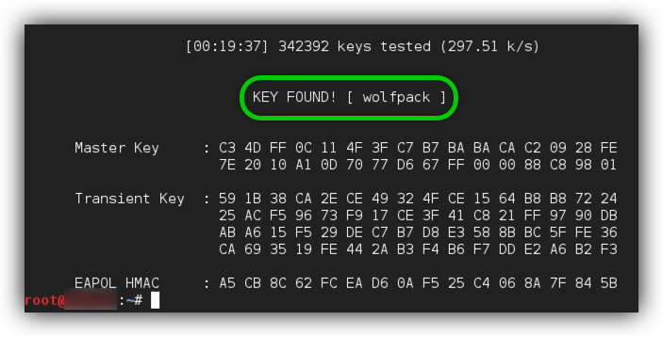

Figure 4-1: aircrack can crack WEP, WPA and WPA-2 keys after sniffing enough packets.

cain and abel
cain and abel is actually a password recovery tool for windows. It is used for easy recovery of several types of passwords through the following methods:
• Sniffing the network
• Cracking encrypted passwords using dictionary, brute-force, and cryptanalysis attacks
• Recording VoIP conversations
• Decoding scrambled passwords
• Recovering wireless network keys
• Revealing password boxes
• Uncovering cached passwords
• Analyzing routing protocols
The following are some of the features of Cain & Abel:
• 802.11 Capture Files Decoder can decode wireless capture files from Wireshark and/or Airodump-ng containing WEP or WPA-PSK encrypted 802.11 frames.
• Password decoders can be used to immediately decode encrypted passwords from several sources such as the Windows Protected Store, the Credential Manager, standard edit boxes, LSA secrets, passwords from SQL Enterprise Manager, Windows Mail, dial-up, Remote Desktop profiles, and the Windows Wireless Configuration service.
• WEP Attack, shown in Figure 4-2, covers the same functionality as Aircrack and can quickly recover 64-bit and 128-bit WEP keys if enough unique WEP IVs are available.
• Wireless Scanner detects Wireless Local Area Networks (WLANs) using 802.11x.
• Wireless Zero Configuration Password Dumper enables the recovery of wireless keys stored by Windows’s Wireless Zero Configuration Service.

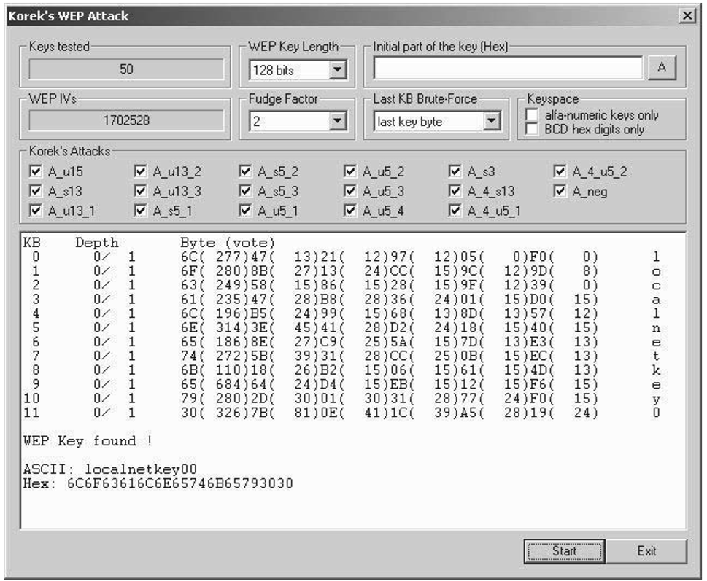

Figure 4-2: cain and Abel’s WEP attack has the same functionality as Aircrack.

